Low fidelity Sketches for Brain Brawl

1. Login page (image 1)
2. Home screen (image 1)
3. Selecting topics (image 1)
4. Match making (image 1)
5. During the quiz (image 2)
6. Results (image 2)
7. Selecting the difficulty level (image 2)

(Image 1)

(

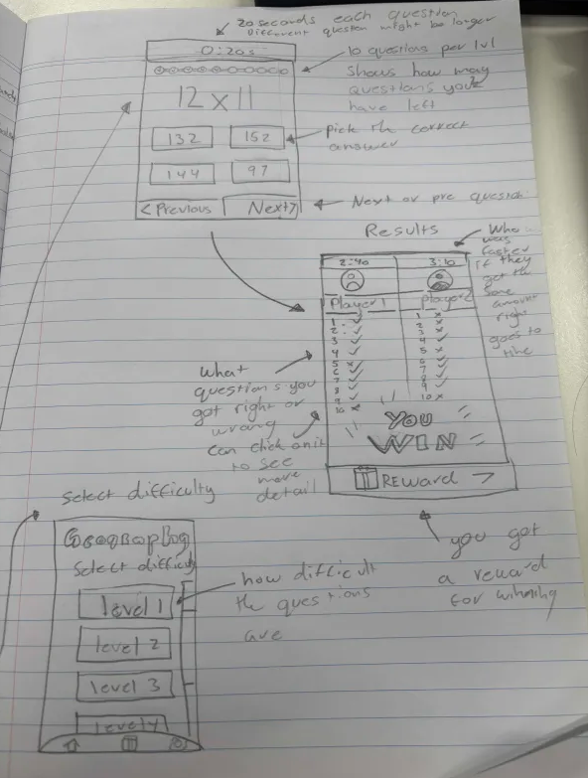(image 2)